“If you can tell me first where we are and where we are headed, I can better tell you what we should be doing and how to do it.” --Abraham Lincoln

RECAP last week:
- Seven day creation/7000 year week
  - Pattern, model (mini)
  - Cole
  - Literal DAYS of creation represent thousand year segments of life on earth
- God is telling a story
  - First ten generations
“Man replaced [with] mortal sorrow. G-d the Blessed One shall come down teaching. His death shall bring the despairing rest.”
  - God keeps time different than the world
    - Jewish calendar is based on the cycles of the moon [Lunar]
    - Each month begins with a new moon
    - The Israelites did not name the months until after their Babylonian captivity. Until then, their months were simply numbered.
    - The days of the week are not named, but numbered. So Sunday is Day One or the First Day, Monday is Day Two or the Second Day, and so on…
Sunday – Day One – First Day
Monday – Day Two – Second Day
Tuesday – Day Three – Third Day
Wednesday – Day Four – Fourth Day
Thursday – Day Five – Fifth Day
Friday – Day Six – Sixth Day
Saturday – Day Seven – Seventh Day [Sabbath]
  - Jewish festivals/feasts are REHEARSALS
    - “feast” = “to keep an appointment”
14 Nisan – Pesach {Passover} (Mar/Apr)
15-21 Nisan – Hag HaMatzot {Feast of Unleavened Bread} (Mar/Apr)
16-17 Nisan – Yom HaBikkurim {Feast of First Fruits) (Mar/Apr)
6 Sivan – Shavuot {Pentecost or Feast of Weeks} (May/June)
1 Tishri – Rosh Hashanah {Feast of Trumpets or New Year} (Sept/Oct)
10 Tishri – Yom Kippur {Day of Atonement} (Sept/Oct)
15-21 Tishri – Sukkot {Feast of Booths or Tabernacles} (Sept/Oct)

Alf and Julie Saunders website: “Pray for Zion”:
http://www.pray4zion.org/index.html
Keep in mind the Jews keep their dates by two different calendars: a religious calendar and a regular calendar, neither of which begin in our January…
Jewish Calendar Year* Jewish Religious Year**
Tishri (Sept/Oct) Nisan (Mar/Apr)
Heshvan (Oct/Nov) Iyar (Apr/May)
Chislev (Nov/Dec) Sivan (May/June)
Tevet (Dec/Jan) Tammuz (June/July)
Shevat (Jan/Feb) Av (July/Aug)
Adar (Feb/Mar) Elul (Aug/Sept)
Nisan (Mar/Apr) Tishri (Sept/Oct)
Sivan (May/June) Heshvan (Oct/Nov)
Tammuz (June/July) Chislev (Nov/Dec)
Av (July/Aug) Shevat (Jan/Feb)
Elul (Aug/Sept) Adar (Feb/Mar)
*Counting of years and chronology **counting of reigns of kings and kingship years in Israel
Seven primary feasts and festivals:
We’re going to look at them in a couple different ways.
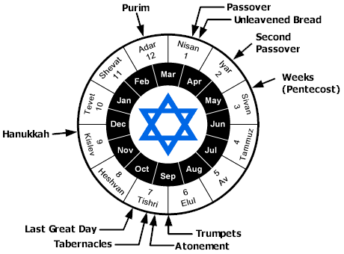

Nisan is their first month on their religious calendar, which is the calendar they keep for their “Holy Days” (holidays). The first day of Nisan is considered their New Year’s Day. It was instituted as such to Moses in Exodus 12:2:
Ex 12:2 NASU
This month shall be the beginning of months for you; it is to be the first month of the year to you.

God instituted the Passover in that same passage of Exodus 12. It is to occur in 14 Nisan every year, [Exodus 12:6]. Known in its Hebrew as “Pesach”, “to pass over, to exempt or to spare”.
14 Nisan: PASSOVER [Pesach]
Explain Passover from the Israelites captivity in Egypt, tenth plague [death of firstborn], blood on the doorpost, death angel will pass over…
Immediately following the Passover is the Feast of Unleavened Bread, 15-21 Nisan.
15-21 Nisan: FEAST OF UNLEAVENED BREAD [Matzot]
- Remove all leaven (yeast) from home, symbolic of sin
- Originally the Israelites did not have time to let their bread rise as they had to leave Egypt at night, in a hurry, and made unleavened bread to eat.
- Matzah (Matzo) = unleavened bread, unfermented process
  - This bread is pierced and striped.
- The first and last (15th and 21st) of these seven days are considered “high holy days”, or in other words, they are treated like Sabbaths where no work is done, and they rest
Immediately after the Feast of Unleavened Bread begins, the very next day is the third feast, the Feast of Firstfruits.
16 Nisan: FEAST OF FIRSTFRUITS [Bikkurim]
- This is a celebration of the spring barley harvest.
- The Israelites traditionally did a “wave offering” of the first sheath of the harvest, giving thanks to God.
6-7 Sivan: FEAST OF PENTECOST [Shavuot]
- Occurs the fiftieth day of the firstfruits. [“Pentecost” = fifty days]
- “Shavuot” means “week” and it is exactly seven weeks and one day later.
- It is a harvest festival. New grain offerings are made.
These are the spring feasts/festivals. Now let’s look at the fall/autumn festivals.
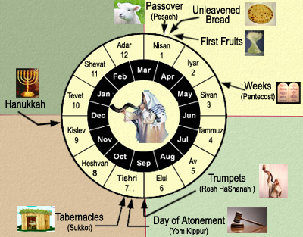

Jewish Calendar Year* Jewish Religious Year**
Tishri (Sept/Oct) Nisan (Mar/Apr)
Heshvan (Oct/Nov) Iyar (Apr/May)
Chislev (Nov/Dec) Sivan (May/June)
Tevet (Dec/Jan) Tammuz (June/July)
Shevat (Jan/Feb) Av (July/Aug)
Adar (Feb/Mar) Elul (Aug/Sept)
Nisan (Mar/Apr) Tishri (Sept/Oct)
Sivan (May/June) Heshvan (Oct/Nov)
Tammuz (June/July) Chislev (Nov/Dec)
Av (July/Aug) Shevat (Jan/Feb)
Elul (Aug/Sept) Adar (Feb/Mar)
*Counting of years and chronology **counting of reigns of kings and kingship years in Israel
Remember that in the Jewish religious calendar, Tishri is the seventh month, but in the civil calendar it is the first month.

The first fall feast/festival is the Feast of Trumpets on 1 Tishri.
1 Tishri: FEAST OF TRUMPETS [Rosh Hashanah]
- Rosh Hashanah means “head of the year” – hence first day of the other keeping of days
  - It’s considered another New Year’s Day
- It’s a holy day that is celebrated with trumpet blasts.
- Celebrate the New Year with feasting and celebration.

Ten days follow Rosh Hashanah, that are called the “days of awe”.
Ten “days of awe”
Repentance
Forgiveness
Restitution

Then on the tenth of Tishri is the supreme Holy Day: the Day of Atonement.

10 Tishri: DAY OF ATONEMENT [Yom Kippur]

- High Priest enters the Holy of Holies to offer a complex set of sacrifices
  - They take a goat outside the city walls to die
- The High Priest invokes the Aaronic blessing on the people, the only time in the year in which the holy name of YHWH (YHVH) is spoken.
- The day was spent in the synagogue repenting, asking forgiveness and petitioning for another year to be written for one’s self in the Book of Life.

15-21 Tishri: FEAST OF TABERNACLES (Booths) [Sukkoth]

Five days later is the Feast of Tabernacles, a joyous occasion in Israel.
- 7-day festival of rejoicing
- Dwell in 3-sided booths or tents
- Ceremonies of light and water

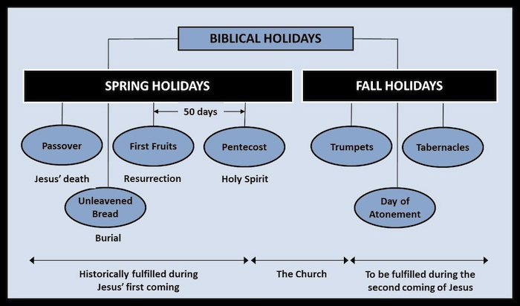

Now we’re going to look at how the first four festivals have been fulfilled in Christ.

The Passover represented the sacrificial lamb that was slain to exempt the children of God from the penalty of death. Jesus was the Passover Lamb.

John 1:29-30 NASU

The next day he saw Jesus coming to him and said,
"Behold, the Lamb of God who takes away the sin of the world!”

Isa 53:7 NASU

He was oppressed and He was afflicted,
Yet He did not open His mouth;
Like a lamb that is led to slaughter,
And like a sheep that is silent before its shearers,
So He did not open His mouth.

Jesus was crucified on the Passover.

Luke 22:7-13 NASU

Then came the first day of Unleavened Bread on which the Passover lamb had to be sacrificed. And Jesus sent Peter and John, saying, "Go and prepare the Passover for us, so that we may eat it." They said to Him, "Where do You want us to prepare it?" And He said to them, "When you have entered the city, a man will meet you carrying a pitcher of water; follow him into the house that he enters. "And you shall say to the owner of the house, 'The Teacher says to you, "Where is the guest room in which I may eat the Passover with My disciples?"' "And he will show you a large, furnished upper room; prepare it there." And they left and found everything just as He had told them; and they prepared the Passover.

Jesus’ crucifixion is our redemption.

1 Peter 1:17-21 NASU

If you address as Father the One who impartially judges according to each one's work, conduct yourselves in fear during the time of your stay on earth; knowing that you were not redeemed with perishable things like silver or gold from your futile way of life inherited from your forefathers, but with precious blood, as of a lamb unblemished and spotless, the blood of Christ.

For He was foreknown before the foundation of the world, but has appeared in these last times for the sake of you who through Him are believers in God, who raised Him from the dead and gave Him glory, so that your faith and hope are in God.

READ Revelation 5: [This is the LAMB OF GOD.]

…For Christ our Passover also has been sacrificed. [1 Cor 5:7 NASU]

Jesus is our Passover Lamb

This Feast was also the traditional Last Supper.

Ex 12:18-19 NASU
In the first month, on the fourteenth day of the month at evening, you shall eat unleavened bread, until the twenty-first day of the month at evening.

Luke 22:7-13 NASU
Then came the first day of Unleavened Bread on which the Passover lamb had to be sacrificed.

See: Matthew 26:17-30, Mark 14:12-25, Luke 22:1-23

The Matzah (unleavened bread) used is pierced and striped, symbolic of Christ’s punishment and death.

The Feast of Unleavened Bread is symbolic also of Christ’s burial, in which sin (leaven) is done away with by Christ’s sacrifice on the cross.

Christ was resurrected on the Feast of Firstfruits, the third day. Crucified the 14th, buried the 14, 15, 16. Rose on the 16th.

1 Cor 15:20-25 NASU

But now Christ has been raised from the dead, the first fruits of those who are asleep. For since by a man came death, by a man also came the resurrection of the dead. For as in Adam all die, so also in Christ all will be made alive. But each in his own order: Christ the first fruits, after that those who are Christ's at His coming, then comes the end, when He hands over the kingdom to the God and Father, when He has abolished all rule and all authority and power.

Christ is the fulfillment of the Feast of Firstfruits

Lastly, let’s look at the Feast of Pentecost.

Pentecost is a harvest festival in which new grain offerings are made. Two loves of leavened bread are brought before the Lord and waved as an offering of thanksgiving. It’s understood that the two leavened loaves represent Israel and the Church.

The Firstfruits of the New Covenant were birthed here, fifty days after Christ’s resurrection.

Acts 1:1-5 NASU

The first account I composed, Theophilus, about all that Jesus began to do and teach, until the day when He was taken up to heaven, after He had by the Holy Spirit given orders to the apostles whom He had chosen. To these He also presented Himself alive after His suffering, by many convincing proofs, appearing to them over a period of forty days and speaking of the things concerning the kingdom of God. Gathering them together, He commanded them not to leave Jerusalem, but to wait for what the Father had promised, "Which," He said, "you heard of from Me; for John baptized with water, but you will be baptized with the Holy Spirit not many days from now."

If Christ was resurrected on the Feast of the Firstfruits and He appeared to the disciples forty days after, how long did they have to wait? What was “not many days from now”?

Must have been ten days later…

Acts 2:1-4 NASU

When the day of Pentecost had come, they were all together in one place. And suddenly there came from heaven a noise like a violent rushing wind, and it filled the whole house where they were sitting. And there appeared to them tongues as of fire distributing themselves, and they rested on each one of them. And they were all filled with the Holy Spirit and began to speak with other tongues, as the Spirit was giving them utterance.

And here we have the birth of the Church, the real Church, or to be more exact, the Body of Christ’s birth with His spirit.

Now let’s look at the Feasts of God again, and let’s keep in mind they were considered “rehearsals” or “to keep an appointment”…

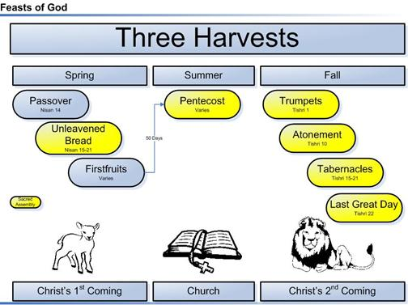

Are you starting to see the patterns? Can you see how God has shown us what will come from what has been? Remember Ecclesiastes?

Eccl 1:9 NASU

That which has been is that which will be,
And that which has been done is that which will be done.
So there is nothing new under the sun.

Eccl 3:14-15 NASU

I know that everything God does will remain forever; there is nothing to add to it and there is nothing to take from it, for God has so worked that men should fear Him. That which is has been already and that which will be has already been, for God seeks what has passed by.

And do you remember this from last week?

Isa 46:8-10 [Complete Jewish Bible]
Remember this, and stand firm. Keep it in mind, you rebels.
Remember things that happened at the beginning, long ago —
that I am God, and there is no other; I am God, and there is none like me.
At the beginning I announce the end, proclaim in advance things not yet done;
and I say that my plan will hold, I will do everything I please to do.

Now when you begin to understand patterns, symbols and signs God has outlaid, you will start to pick up a lot more. Your knowledge will increase. Let’s look at a current sign for fun….

Remember God said…

Gen 1:14 NASU

Then God said, "Let there be lights in the expanse of the heavens to separate the day from the night, and let them be for signs and for seasons and for days and years;

Keeping that in mind, let’s talk about the four blood moons coming…

Jewish Talmud says, “When the moon is in eclipse, it is a bad omen for Israel. If its face is red as blood, [it is a sign that] the sword is coming to the world.”

A blood moon is a lunar eclipse in which the color of the moon appears dark red, like blood. Four total blood moons in a row is called a “tetrad”.

Let’s consider some history…

Oct 18, 69 A.D. partial lunar eclipse Feast of Sukkot
Mar 30, 70 A.D. total solar eclipse New Years Day [Nisan 1]
Apr 14, 70 A.D. penumbral lunar eclipse Passover
Sept 23, 70 A.D. annular solar eclipse Rosh Hashanah
Oct 8, 70 A.D. penumbral lunar eclipse Feast of Sukkot

[Feb-Aug] 70A.D. Destruction of the Temple, burning of Jerusalem

In the past 2000 years, there have only been seven tetrads. The eighth is coming in a couple weeks…
There will not be another in over a hundred years.

Four PARTIAL lunar eclipses occurred on the Jewish Passover and Feast of Tabernacles in 32-33 A.D.

Seven tetrads followed over the next 2000 years:

Passover/Feast of Tabernacles 162-163 A.D. – considered the worst persecution of Jews and Christians in the history of the Roman Empire. About three years later one-third of the Roman empire population was destroyed by the Antonine Plague.

Passover/Yom Kippur 795-796 A.D. – King Charlemagne of the Holy Roman Empire established a DMZ buffer zone (demilitarized zone) between France and Spain, ending centuries of Arab invasions into Western Europe.

Passover/Yom Kippur 842-843 A.D. – Islamists from Africa invaded, attacked and looted the Vatican church in Rome.

Passover/Yom Kippur 860-861 A.D. – Arab armies defeated at the Battle of Lalakaon (Turkey) by the Byzantine Empire, which permanently stopped the Islamic invasion of Eastern Europe.

Passover/Feast of Trumpets 1493-1494 – King Ferdinand and Queen Isabella issued an edict that all Jews be removed from Spain [200,000 Jews expelled from Spain]. Tens of thousands were murdered. Christopher Columbus was credited with “discovering America”.

Passover/Feast of Tabernacle 1949-1950 – Arab/Israeli War for Independence. May 14, 1948 Israel declared its independence, less than 24 hours later Egypt, Jordan, Syria, Lebanon and Iraq’s armies invaded , war lasted 15 months and 6000+ Jews died (1% of the Jewish population).

Passover/Feast of Tabernacle 1967-1968 – Six-Day War, Israel recaptured Jerusalem as its capital, Judea, Samaria, Gaza, the Sinai Peninsula and Golan Heights were returned to Israel.

Now here comes number eight.

- April 15, 2014 Passover
- October 8, 2014 Sukkot
- *[March 20, 2015 Nisan 1 (New Year)]*
- April 4, 2015 Passover
- September 28, 2015 Sukkot

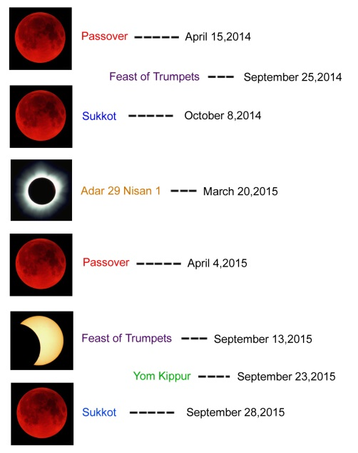

Joel 2:30-32 NASU

I will display wonders in the sky and on the earth, blood, fire and columns of smoke.
The sun will be turned into darkness and the moon into blood
Before the great and awesome day of the Lord comes.
And it will come about that whoever calls on the name of the Lord will be delivered;
For on Mount Zion and in Jerusalem there will be those who escape,
As the Lord has said, even among the survivors whom the Lord calls.

Joel 3:13-17 NASU

Put in the sickle, for the harvest is ripe.
Come, tread, for the wine press is full;
The vats overflow, for their wickedness is great.
Multitudes, multitudes in the valley of decision!
For the day of the Lord is near in the valley of decision.
The sun and moon grow dark and the stars lose their brightness.
The Lord roars from Zion and utters His voice from Jerusalem,
And the heavens and the earth tremble.
But the Lord is a refuge for His people and a stronghold to the sons of Israel.
Then you will know that I am the Lord your God, dwelling in Zion, My holy mountain.
So Jerusalem will be holy, and strangers will pass through it no more.

Matt 24:29-31 NASU

But immediately after the tribulation of those days THE SUN WILL BE DARKENED, AND THE MOON WILL NOT GIVE ITS LIGHT, AND THE STARS WILL FALL from the sky, and the powers of the heavens will be shaken. And then the sign of the Son of Man will appear in the sky, and then all the tribes of the earth will mourn, and they will see the SON OF MAN COMING ON THE CLOUDS OF THE SKY with power and great glory. And He will send forth His angels with A GREAT TRUMPET and THEY WILL GATHER TOGETHER His elect from the four winds, from one end of the sky to the other.

Luke 21:25-28 NASU

"There will be signs in sun and moon and stars, and on the earth dismay among nations, in perplexity at the roaring of the sea and the waves, men fainting from fear and the expectation of the things which are coming upon the world; for the powers of the heavens will be shaken. Then they will see THE SON OF MAN COMING IN A CLOUD with power and great glory. But when these things begin to take place, straighten up and lift up your heads, because your redemption is drawing near."

Rev 6:12-17 NASU

I looked when He broke the sixth seal, and there was a great earthquake; and the sun became black as sackcloth made of hair, and the whole moon became like blood; and the stars of the sky fell to the earth, as a fig tree casts its unripe figs when shaken by a great wind. The sky was split apart like a scroll when it is rolled up, and every mountain and island were moved out of their places. Then the kings of the earth and the great men and the commanders and the rich and the strong and every slave and free man hid themselves in the caves and among the rocks of the mountains; and they said to the mountains and to the rocks, "Fall on us and hide us from the presence of Him who sits on the throne, and from the wrath of the Lamb; for the great day of their wrath has come, and who is able to stand?"

