Dr. Charles Morgan on Psycho-Neurobiology and War
97,798 views
•Jun 14, 2018
Modern War Institute
13.8K subscribers

Dr. Charles Morgan speaks to cadets and faculty at West Point about a range of topics, including psychology, neurobiology, and the science of humans at war. Dr. Morgan's neurobiological and forensic research has established him as an international expert in post-traumatic stress disorder, eyewitness memory, and human performance under conditions of high stress. The event was organized and hosted by the Modern War Institute at West Point.

Intro from Modern War Institute at West Point, [video: June 14, 2018] Today we have Dr. Charles Morgan talking to us about neuroscience and psychology and the whole gamut of things right now. He is a professor of national security studies at the university of New Haven. His focus is teaching national security studies domestic and international intelligence analysis and issues in deception.
Dr. Morgan is developing a concentration in the human aspects, intelligence analysis, and psychological operations arenas that are relevant to the intelligence community. He has a pretty robust background with military folks doing research at SERE School helping with selection processes for special operation forces….Fort Bragg, etc.
TRANSCRIPT OF DR. MORGAN’S PRESENTATION:
Actually I was in the Navy. It wasn’t Army but I’ve done more work with the Army over all these years than I ever did with the Navy.
What I would like to talk to you a little bit about today is something I was asked to do in 2010 and 2011. I was getting ready to leave over at the CIA where I had worked for a number of years and the Intelligence Science Board said, “could you give us a brief on what’s in store for us in the future?”
I was like, I don’t know. Predicting the future is really hard. So I told my boss at the time, I said, “Well I think the best I’ll do is make an estimate over what I think is going to happen over the next five years, given certain technologies that were being developed at the time.” And this is a bit of an extension of that. I presented it to the SSG and it was some information I think some people didn’t know. I think it’s good for people to be aware of what’s going on out there.
The one thing that makes predicting a little bit of the future easier when you look at biomedical science is that labs are working fairly systematically with overtly stated goals. So if you think about it, science is not really done in a haphazard way. It takes time, preparation, you have to test multiple hypothesis, develop techniques. So it is not really rocket science to look at a lab and say, “this is where they’re going. And here are probably two of the Achilles heel points in the design but if they surmount those they will probably achieve what they say they want to do.”
So that’s a little bit of what this is about. I was going to give you my thoughts on Mind, Body and Beyond, gene slicing, Dr. Venter’s work, DNA encrypting and something about the past, that it is not what it used to be.
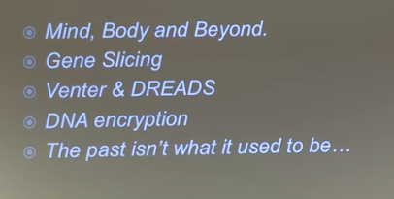
What I’d like you to consider for a minute is that one of the things that most people have a hard time understanding is that there’s a difference between our mind and our body. Your personal experience is usually of an integrated operating system since the time you were little. However, there has been a plan in many labs to figure out how do we help people whose bodies don’t work in the way that they want them to do, who have neurologic defects.
So as a way of surmounting that, people are experimenting. Five or six years ago, or as early as 2008 with whether or not you could do a brain robotic interface.
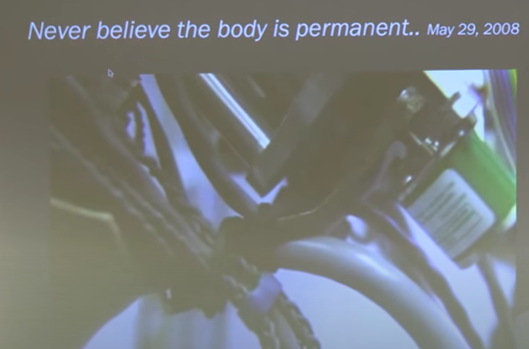
[video of monkey using brain control over a robotic arm – biofeedback closed loop]
So essentially when you are little and are growing up and learning how to work your appendages, you are making good motor neuron connections and inhibitory connections. What they’re able to back in 2008 with a primate, is have it learn through trial and error that by thinking it can move a robotic arm and feed itself. It didn’t take too long for the neural interface issue to be resolved once people figured out you could implant electrodes on brain tissue and then take a biological signal and turn it into an electrical signal and amplify it.
It took a little while for the monkeys to figure out how to do it early on. They would give it a little joystick so it was like playing a video game. [After awhile the monkeys figured out they didn’t have to use the joy stick and could just think about it to get the arm to move.] And the monkey would begin to experiment and would think about where it wanted the arm to go so it was learning it had a new appendage. The same is true in people.
You can see just four years later we see it being done in humans.
5:53 [people with neurological injuries who can’t use their limbs]
[11:18] So what you see is people struggled with how to get the electrodes on the surface of the brain, how to do the brain learning. The computer algorithms have improved. This is by trial and error as it begins to recognize what the subject’s brain is doing. But after that, if you look at that as a scientific development in medicine, you can quickly see the possibilities that emerge. They’re playing with motor function and linking it to thought.
So the next step really when you think about it was to simultaneously try it with another non-human animal and find out if she could run a robot on the other side of the planet. And the essence of this experiment is at first she had to walk on the treadmill to keep the robot walking that she could observe on a computer screen. Then she just stopped walking and it would run the robot in Japan. So you can have a brain here in the United States plugged in running a robotic device, a mechanical device via the internet somewhere else in the world.
…Where do you see this going? See it as an offensive or defensive opportunity with respect ot the intelligence community.
The natural segue then would be if I can send motor function from a brain to a mechanical arm, is it possible to send motor functions from one human to another human? So I call it the possession experiment.
[RT news report video at 12:59]
[15:15] Essentially what’s happening is when one person is playing the video game, they’re not using their hands. They’re simply looking at targets. What’s going on in the other room is a transcranial magnetic stimulation that creates a magnetic field that excites neurons. And it’s the other man’s hand that begins to move and hits the targets.
So you’ve co-opted the portion of a body of another human and then their hand can behave in the way that you want it to do. His goal (you’ll see later if you download the video) is he would like to have a cap that you could put on and have a surgeon direct your hands to do battlefield surgery or something somewhere else in the world where they don’t have a doctor who has the technical skills. You can put on the cap and your hands become an extension of that expert’s body. The fine motor skill manipulation at that point in time was not great but the person on the receiving end described the sensation as rather odd – said, “I didn’t know anything until I saw my hand beginning to move.” And felt that it was something other and his hand was moving. His hand could punch in a code, and could do a number of things. But the really fun part was that you’re taking over somebody else’s physical body with the mind of another human.
So what do you think would be the next step? If you follow medical research you say you can make a robot move. You can make a human hand move. What would you do next? Wow. They’re getting brains connected to run things. Can you actually send and receive sensory information, like the Matrix? Yes.
[17:45 video brain to brain interface in rats on Telegraph]
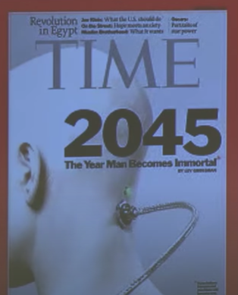

[19:47] So it took some learning trials, but not many. It took 75 between them to achieve an accuracy rate of over 85 percent in just training their rats for a little while in the cages. But this was a milestone because it was not simply using the motor cortex to run a device, this one actually had one animal learn something and seeing and recording that activity and put it into the sensory cortex of the second animal, and that animal acquires the knowledge. It is able to act on the knowledge from the experience for something it has not ever done. Which is really fun when you think about it.
Would this facilitate language learning? Will this let you upload information when you don’t know how to operate a device? Does it serve well for covert communication? This was done between two rats. What we do know is that DARPA did get permission for 500 operations to do deep brain electrode implants. They haven’t published anything yet, but my guess is what you’re looking at is human human thought transference and certainly in the open science world that was published last month. Actually the brain to brain transfer of sensory information into humans they achieved a success rate of being right 85% of the time.
So you can attach one human brain to a device. You can attach the human brain to another human brain. You can direct motor activity, or you can send communication and information. What we know from the training trial data so far is that it probably requires a training trial between people as well. What we don’t know from an encryption and encoding standpoint whether everybody’s communication would follow the same patterns or not. It may be that two people will have to train and then it’s unique and a decryption problem for someone if they decide they can intercept the signal. That would be – but you could plug in somewhere else in the world and learn something or see something or have somebody acquire the information that you have and you wouldn’t have to carry a different device.
There’s a whole world out there of biohacking. I don’t know if you’re aware of it but you should be.
Normally at the University we are well regulated by the federal laws about studying and experimenting on humans. There’s a biohacking community that is not part of the official science community that is busy trying to attach hardware to humans and they do it in their basements. They study up on how to do the surgeries, how to connect devices, how to put motherboards in people, and they may use it for some purposes like fishing, using RFID signals in their hands to take information from you.
But there are some other interesting developments when you start thinking about the fluidity of what you can do with the brain. They’re experimenting with CE6 and giving people with eye drops night vision for several hours. A person receiving the eye drops can see over 160 feet in the dark. It’s a lot easier to look through your own eyes than it is to put on nods.
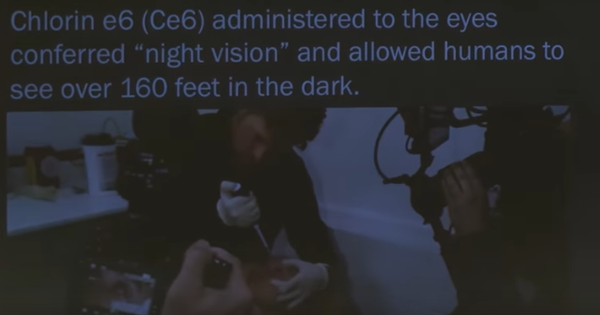
It will be a short time before you can get a better solution than we get from the bio hacking community, but it could also be readily available to almost anybody on the planet. It’s going to be harder to keep this under control than it is to keep the special lenses and night vision technology. So I think it’s really important that people pay attention to this kind of thing because that can give humans the natural ability for awhile to see in the dark.
The other new possibility coming along is that seeing in the dark is something you don’t really naturally do that well but with animals we’ve been able to achieve a number of other things, one of which is giving them an extra sensory ability, if you will.
[23:35 video on giving rats an extra ability – infrared light detection]
[24:33] So people are playing with chemicals to enhance the human capacity. They’re also experimenting now with how do you add a device to the mammalian brain to give it an extra sensory ability? You may not want to detect infrared. You might want to have a room temperature detector of radiation, depending on what your job is in life. So when you think about it, the possibility now is there to develop different kinds of devices. They could be perhaps used either by intelligence people or by people in the military to have an extra ability – to be able to see through walls, to see heartbeats.
We used to play with the 18 Gigahertz microwave detectors where we could pick up heartbeats through anything but solid steel and water, but that could easily be a human who can see a unique heartbeat that’s behind the wall over there that’s thermal insensitive.
So it doesn’t have to be IR; it can be a number of things. Anything that you can co-opt is theoretically now possible to adapt to human brain functioning. All you’d have to learn is the code. You’d have to train with it. It might not be natural at first; you might not understand the signal you’re getting but you can add to human brain function. You can also use it to intercept signals.
The experiment that was just released this last month, as I said, demonstrated that people could transfer knowledge from one human to another.

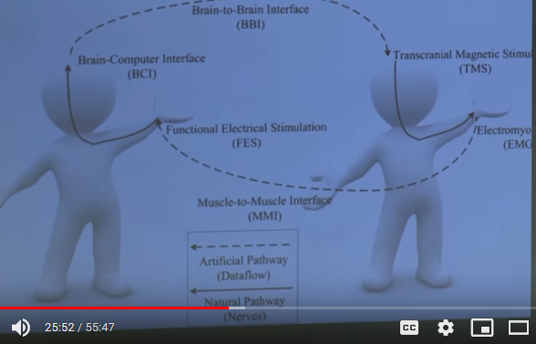

I commented to a couple of my colleagues that I think right now the most direct application of that is going to be either covert communication or running drones. The set of experiments I didn’t have videos to show you, but there have been a series that have shown you can connect the human to a rat and control its motor movement and its tail. So you can have non-human animal drones. You can have the human brain probably run a regular drone at this point but running a non-human drone, something like a cockroach or a rat would be awesome.
If you were watching the Olympics and you see the coordinated maze of drones, the software is now really readily available where you could have hordes of little creatures that can gain access to facilities or move around in different places all run by a person sitting in a booth. It’s no more technically challenging once you do that than figuring out the logistics of how you’re going to send your signal somewhere else in the world and how to protect that signal.
That’s now. That’s not in the future.
In the next five years the interfaces are going to become more delicate, more refined. As transcranial magnetic stimulation – it’s a rather crude instrument right now [2018], it creates a field that excites just hordes of neurons – but as they refine the technology so you can get a better point specificity to the neurons you actually want to activate, you should be able to do this without penetrating the skull. Either someone could wear a cap, in fact that’s how the latest brain to brain communication in humans was done. It was done without surgery and actually signaling via some stimulation to the retina and the brain decoding it. (Although the person consciously didn’t know what the code was, the brain did.)
I would recommend people become aware of that from the human drone technology standpoint.
The second field that people may or may not be aware of…
I wasn’t around when they developed atomic weapons but Dr. Venters work is my view of the equivalent of nuclear weapons when you realize that he created life in a cell back in 2010. This technology paired with something called CRISPR, which is like an editing software for genes, makes a number of things immediately available.
What he did was program yeast cells to produce anything he wanted. They can produce perfume. They can produce petroleum. They can produce any peptide, anything we program the DNA to do, and it’s in the living cell.
The goal in medicine now is to be able to do designer medicine and therapy. If we can design a cell to get into your body and release the right product for you, you won’t be losing half the drugs you take through your liver when you swallow a pill and it gets digested. These can be inserted into you through the hypo spray needles. (almost like Dr. McCoy on Star Trek giving a hyper spray) It just blasts plasmids into your squamous cells. But Venter was able to do that and has the patent on the technology. You can engineer anything. You can engineer a unique thing that would only kill one person in the world.
It’s how it’s done. You put in a specific gene splicing. You program what you like. You put it in the cell and it can reproduce and make as much as you like.
Your DNA is wrapped up in tight little coils. So what you’re doing was when you create plasmids and put them into cells it sends a signal and tells which portion of the DNA should unwrap, unfold, and produce a product.
This is the future of medicine. When you look at this technology in medicine and say this is going to be done to help people right, we want to be able to give them medicine so we actually want to correct for genetic deficits. If a kid’s born with a genetic anomaly, with the CRISPR technology the feeling is we can create the portion of the gene they’re missing and go have it spliced back in. And that may help the child, either if it’s in utero development or once they’re older, to have the missing substance actively produced.
What would you do with this if you were in security or intelligence? You could do a number of things. You could decide if you make this gene you know that certain people in the world who function at very high altitudes very very well do it because they had a special mutation in their genome that we don’t have because we didn’t grow up in the Himalayas, but they can function at very high altitudes. Could you give this to people who are going to have to do war fighting in high altitudes and they don’t require extra support? Their body makes much more efficient use and can work under conditions of lower oxygen than the rest of us. Start letting your mind wonder….
Can it also produce a substance that lets you function longer underwater without oxygen? These are run by certain mutations in genes and with CRISPR we have the ability to actually make these and see what happens when we give them to animals, non-human or human animals that don’t have it naturally.
You have the Forrest Gump gene…
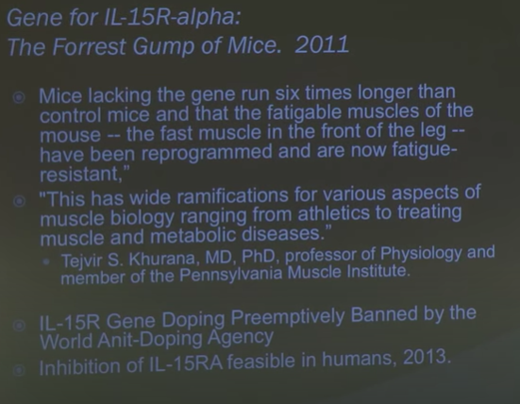
There’s a gene that just makes you stronger.
I would say that most of this technology is probably going to be employed by a State and not non-state actors because it’s quite technical. But I say that with a caveat. When we study the [uma Shinrikyo?], if people remember right they had both uranium mines and regular laboratories where they experimented on both animals and had a whole series of laboratory experiments to develop the different kind of gases they wanted. Their goal was to actually mine uranium and probably come up with their own version of a nuclear weapon, but they recruited scientists, PhD level folks, and their goal was to be their rightful people running the country of Japan. But we can’t assume just because they’re non-state actors they will not make use of some technology around this.
Related to this is an idea called DREADDs.
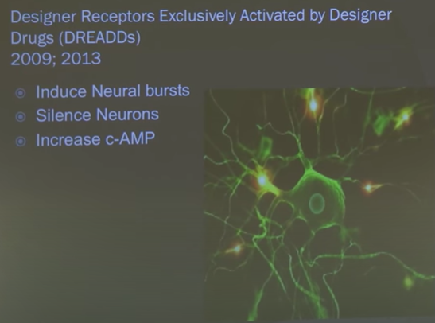
These are designer receptors that can be remotely controlled. You can create a designer receptor. You can create a cell. You can put it somewhere in the body and you can remotely activate it when the brain is exposed to the right signal.
Using this technology people have been able to transfer memories from one fruit fly to another by signaling through a light stimulus into the retina. Right now in most animals it’s done by putting a substance into their body that will actually activate the neuron in the way that you want it.
So you have the capacity to create any product as long as you know the DNA sequence. You can insert it into a living system, and you can remotely control it.
In medicine we think about it as how we do that to help people, how we do to repair deficits. Other people are going to think about how to expand possibilities. One of the challenges that we have is that when you create a cell and you put it in somebody’s body, you have to figure out where you want it. What if you want it in their brain? If you want it in their brain and you can’t figure out – you don’t want to do surgery to plant it in their brain – if I want a product produced in your brain that may affect the way you think, the way you act, one route to that is through stem cells.
Stem cells are also called god cells. They can turn into anything. They hold the potential, unlike other cells in your body, to become anything you want them to become. And they can go find their home in the body and park there and do the work that you’d like them to do.
You can infuse them and they will find their way into the brain. So once you know the technology is there to edit, splice and program a cell and the technology currently exists to administer to somebody and have it go park anywhere you program it to go, park, proliferate, and do its function, you can have things activated in other people’s brains.
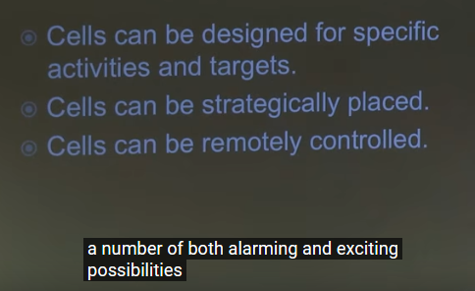
So you take these three key points, hopefully you can see it opens up a number of both alarming and exciting possibilities. You can have the time to release of information on demand. Hopefully when I mentioned the word CRISPR and word editing and creating molecules with CRISPR and playing with DNA, some of you thought encryption and encoding.
DNA encryption – there were I think eight articles published by China in the course of three years in the last three years and it’s quite important. The coding system, DNA steganography, I’ll just say the short story on this is people have figured out how to hide imagery in the DNA of bacteria. And when you [unintelligible] the bacteria you can discover the information or you can have the information reproduced in a string format as a form of a protein.
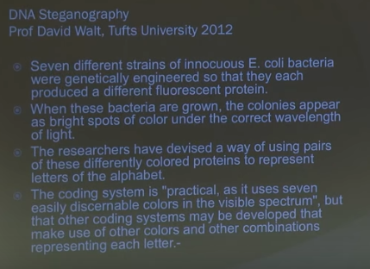
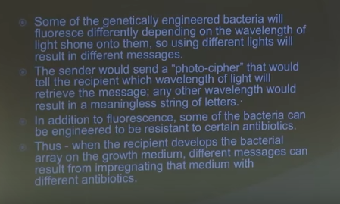
Dr. Church, up at Harvard, has shown quite well that you can store a lot of information in one gram of DNA.
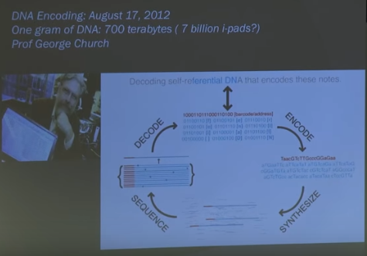
It’s essentially, yeah, that many ipads in one gram, at room temperature. No super cooling required. DNA is highly stable. It’s been around on the planet a very long time.
So between CRISPR, the storage capacity and programming cells, the new way to hide information is going to be in DNA. The commercial application is going to be a bit like on Star Trek years ago: “why would you have a digital system when you can have a DNA system? Can store all the information you’d ever need…records, photos, anything. It’s simply another way of storing information. It had just been so slow up until five years ago, it wouldn’t be thought to be practical. But it is.
This is the first experiment showing what imagery you can hide in bacteria.
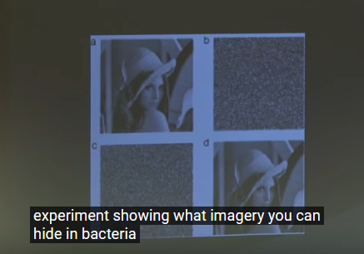
This is the latest. It’s a GIF file. It was actually programmed into the DNA of bacteria last year. The bacteria reproduced and the offspring from the reproduction cycle would still produce this movie:
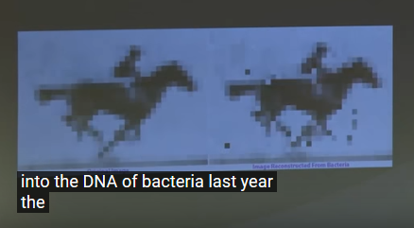
You can hide information into bacteria. And when the bacteria multiply, they can go into spore form and last for a very long time. No one can scan you and find bacteria. We don’t have anything that can detect that.
So if you want to be able to encode information, take pictures of information, create something in DNA and don’t want it in your own body, it can be bacteria on some portion of your body. All they have to do is scrape it, let it grow in the petri dish and unpack the information. This is all available now. This isn’t science fiction, but you can encode movies. 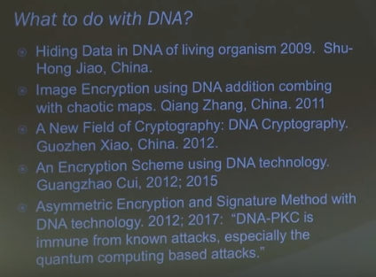
This is what the Chinese are doing with DNA. So in your own neck of the woods you can begin inquiry.
We are doing things with DNA as well but the Chinese are fairly convinced that DNA encryption encoding would be one tremendous challenge even for quantum computing. So this is where the race is right now [2018], trying to merge quantum computing with what you call a wet hard drive with DNA. Merging DNA systems with quantum computing will be really quite an amazing and both lethal threat for that.
The next thing I wanted to mention to you is memory.
[38:11 played a clip from Men In Black where they erase her memory with a light stick]
[38:40] So what to do with memory? In medicine we think of memory as a potentially harmful thing when people present with post-traumatic stress disorder. They can’t stop thinking about the thing that’s creating emotional distress. It’s a very active development in the field to figure out can we erase memory? Can we modify memory? Can we change memory? Short answer is yes.
Several years ago with the PKMzeta (and ZIP – the inhibitor) data out of Duke University, this was the first time anyone had ever demonstrated that if you wash an area of the brain called the hippocampus – it’s an area of our brain that’s crucial for forming short memories, spatial memories, and then facilitating the transfer from a short term memory, to something that’s more permanent and stable over time – that he could train the mice to run the maze, document the number of trials and errors, and then flood their hippocampus or expose it to this, and the memory would be completely gone. Meaning when the rats or the mice had to learn it over again, it was the same number of learning trials. There was no trace of the memory left.
The good news for us when we study rats and mice is we put electrodes and cannula into their brain and can directly affect that area of the brain. If you wanted to poke your own hippocampus you’d have to stick your finger through your eye and go right back in there. Sounds impossible to get to. Not if you program a cell to go there.
So if you decide you wanted to program something that was selectively release PKM zeta after your meeting with someone, they probably would have no memory of it. That’s what’s happening in the rats.
The technical challenge right now is, how do we get a cell in there to do that in human? I can assure you they’re working on that in non-human primates right now. How many? What’s the point specificity? Can we get it in there close enough to the hippocampus? Will those cells start reproducing in the next day make enough of that stuff to wipe out a memory?
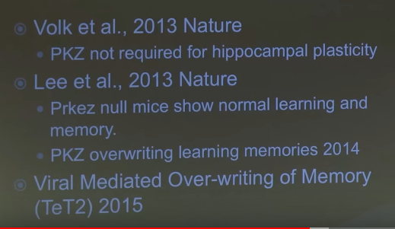
Related to this, once you start thinking about memory, are chemicals that not only wipe out memory, but chemicals that enhance it… So if you want a better human camera, a better individual who can just go see and remember everything… that’s the direction that the research in this lane is taking to help people with Alzheimer’s…how to give them memory back.
So what’s being actively are the few people on the planet who have hypermnesia, in other words they remember everything that’s ever happened to them. We’re actively trying to understand how to unlock that and unpack that and figure out why it is their memory does seem to record and they retain everything they’ve seen. They don’t find it pleasant and people in medicine would like to try and understand that so they can turn it into something beneficial for people who are losing memory.
From a security and intelligence standpoint, it is a really unique opportunity to begin to discover, can you administer a drug that enhances human memory for a certain number of hours? Does it have to be permanent? So rather than carrying technical toys somewhere to try and record and collect information, your brain just remembers it, which doesn’t give anybody really anything to detect.
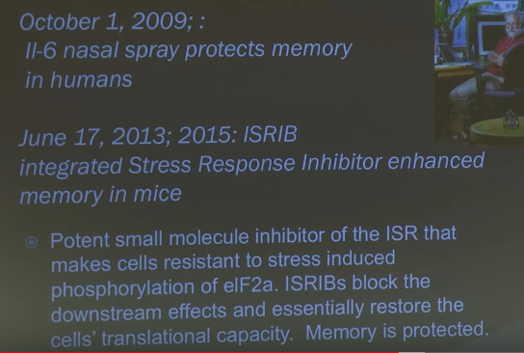
That’s one potential use for it and that’s one lane of research that’s going on.
That research on hyper memory has gone more slowly than I thought in 2010. I thought by about there would be some progress. There hasn’t been much yet in expanding memory very much. It seems to be a harder nut to crack than erasing memory. Erasing memory seems to be far easier.
The last topic I wanted to review with you is memory. I don’t know if you recognize any of the imagery up there (screen) but I’ll walk you through it.
In the last five years what’s been demonstrated is that you train a fruit fly around an aversive experience and you can transfer that memory to the brain of another fruit fly by manipulating the rods and it gives it a memory for something it’s never had before. And then it reacts to the stimulus in the same way as the animal who did have the aversive learning experience.
It’s been done in mice. I’ll talk a little about what [unintelligible] and I have done to men and women going through SERE School and changing memory.
And I’ put the last slide up because this is in flatworks and this came two years ago that memory really is something beyond what we typically understand in flatworms. You can cut their heads off and their body still remembers stuff.
They’re just beginning to decode where and how memory stored in the body of this little creature, so we can translate that into memory in animals that look different than that little creature. It’s evolved for a very interesting reason.
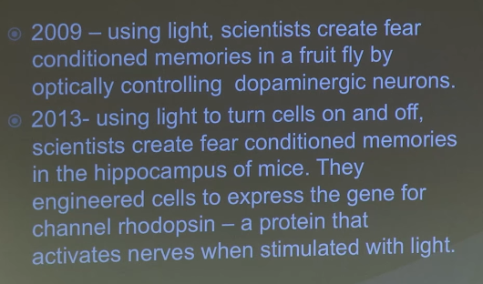
In 2009, using light, they’ve transferred memory. You can turn things on and off using light in animals to activate the hippocampus – turn memory on and off. So where are we with humans in creating false memories, giving memories that they’ve never had? We’ve come a long way.
My colleague is Beth Loftus and this was her early work. It was called “lost in a mall”. What she did was she asked a person to be in the study. You could be in her study if you had a sibling that was at least five years older than you. And she’d say, we’re interested in your memory from when you were a kid. I’ve asked your older sibling, your older brother or sister, to give me four stories about you, and I want to know how much you remember. What people didn’t know is that there were four different stories, but one of them was fake. She wanted to see how long it would take for them to adopt a false memory.
The quick answer is after two interview sessions 30% of the subjects believed that they remembered the person who’d found them when they were lost at a mall and actually argued with the researcher about whether or not the memory was true or not. And that’s how I met her. We decided to get together and run up to Brunswick to see her school and try a memory experiment. This was our design (screen)…
If you’re not familiar with SERE there’s a classroom phase. There’s an experiential phase. We were interested in sampling people when they were in isolation, when they’re returning their gear, and at the end. We tried a couple of different techniques…
Group One there’s no misinformation, we simply want to sample accuracy of human memory for their experience. We told them at the beginning of SERE we want you to be the best little human collector possible. We are going to quiz you about your memory. Don’t let us trick you; we want to know what you remember.
Group Two we told them the same thing but we lied. When we took their questionnaire at the end, we incorporated several techniques from false memory techniques which are a little bit of leading questions to see whether or not we could create false memories.
Group Three we exposed them to an erroneous photograph of their interrogator.
Group Four we used a video.
So this is what we did. By exposing them to a photograph after they had been interrogated and placed in isolation stress, it could change them from this guy to this guy 48 hours later on who they were identifying the lineup.
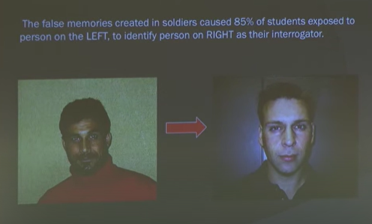
Their level of confidence was an eight out of ten that that was the person they had met.
We found that we could make them believe that there were guns, that there were knives, that there were caches of weapons, simply by altering the phrasing of a question or inserting something into a video.
I’ll give you an example. If we said, did your interrogator wear a weapon? If so, please describe it. We only got about a 2% endorsement of the presence of a weapon in the interrogation phase. If we said, when you were being interrogated by your interrogator and the guy with the weapon interrupted the interrogation, what did they argue about? We didn’t care what the answer was. We’d ask another question to describe the weapon worn by your interrogator? It jumped to 30% would tell us the type of firearm that they had seen in the interrogation booth.
There’s a security violation, right – there weren’t any. We’ve got to record them. But with one question we could do that. When you sample with a few more you can actually increase the sample. So when we increase the stress that’s here, we found that instead of a 30% rate overall we could create false memories in nearly everyone. That was in 900 people.
Beth and I were talking about that. We said well you can change memory, we know that. It’s a way of understanding maybe why and how people have recovered memories of abuse that never happened. That’s what her work has mainly been about. So she decided to do a study called “licked by Pluto”.
She didn’t want to make Mickey Mouse a sex offender but in her lab they thought Pluto was fair game. The short story is people got told they were exposed to some misinformation about a man who was dressed in the Pluto outfit at Disney and he’d been inappropriately rubbing his large fabric tongue on children pleasurably and not pleasurably. There were two different conditions and then there was a neutral condition. If people adopted the false memory and their memory was for something negative, they did not want to buy the Pluto toy – when they went down their list what they would not buy.
She’s done it with food. That was from her series with Alan Alda. She gave him a false memory that he’d been sick one time eating deviled eggs. They offered him one at a picnic on film and you get the classic disgust wrinkle and he said no he got sick one time eating them. It’s not a true memory. It was planted.
She’s done it now with strawberries and ice cream, also done it with pickles and has also done it with alcohol. Study last year was that if you give college students the false memory that they were terribly hung over, they had a wicked hangover from drinking too much tequila, then when they’re given free range options at the bar like a week later, then they decline it at twice the rate of everybody else.
Think about it, if you change the past you change human behavior. We are a case based reasoning animal. When we think about what we’re going to do, we think about the last time we did something, or what we heard about, or what we think it would have done. So to change human motivation we don’t have to persuade people, you can just change their memory.
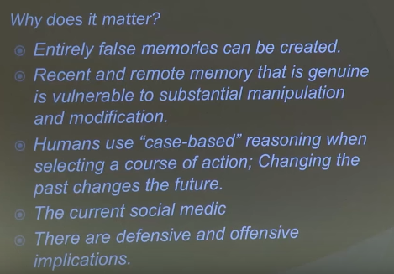
Think about the defensive and offensive capabilities of that.
If you think about this from a defensive standpoint, you have the ability to change the memory of a person who has been debriefed in a safe house about the identities of who they met, the layout. As we’ve looked at altering memory for floor plans, for faces, for timing. If they’re wrapped up by their intelligence service they don’t have anything to lie about or what they remember is actually genuine, but it’s wrong. That might be a defensive way of applying the technique.
In medicine people are arguing about whether or not you can use false memories to help people. Can I give you a false memory that leads you to stop smoking, or is it unethical? Because I can’t tell you I gave you a false memory. I’d have to do it outside of your permission for your good. Most of the things probably unethical in this society, we think you probably should be an informed consumer. But it’s a possibility that you can do.
When I think about this I think about its relevance in this day and age when you start wondering what information is real and what information is trustworthy. You start running into people and debriefing them and you have sources who claim things when you can learn how to create false memories. A person can be genuine and the information they remember --- it’s like the dangle idea – you can (dangle) put information out that’s simply not true. But in the current social media age the ability to actually manage people’s memories and change them is just enhanced, compared to what it used to be. Now you can fix the videos and pictures and expose people to audio and visual information and we know that even if they know that’s a possibility, people don’t recognize when they adopt a false memory. It’s a bit of a Trojan Horse effect. You don’t know that it’s happened to you. If you’re smart and you have a good memory, you’ll believe that happens to other people but not you because your memory is true, so it bypasses some critical reasoning on our part and it’s particularly effective.
Where the state of the art is right now for creating false memories in humans is doing that verbally or by these manipulations with either what we say, what we show them, what we expose them to. But the chemical implanting of memories has now occurred in monkeys.
In trying to restore memory, I would say probably in the next two years we should see the science experiment come out that says a memory has actually been transferred or created and planted back into a human brain that wasn’t done by a classic false memory technique. I would anticipate that’s the direction research is going.
Like how do you rebuild memories in people who have had a TBI? Active research is going on about that on nanite reconstruction of brain, brain cells and brain networks. The idea in the mental health community is people lost part of their brain, we want to restore memory and brain function. Can we put the memories back in?
It’s probably only science fiction for another two years, given the state of the art and the progress.
The last thing I’ll say (and I didn’t have any videos for it – I really wanted to show you one but), the French have published a very interesting paper and it is this…
While people were sleeping, they were able to train them and sample their knowledge on what they trained them in. While they were asleep, and while they were later awake and didn’t know that they’d learned the information.
I’ll say it again, in people who were asleep they were able to tell what people knew around word recognition lists without ever waking the person up. They were also able to train new memory and information outside the person’s awareness while they were asleep.
Where that technology can go is some very interesting places. It would really raise, since I was in the lane of (DSNT?) and we talked about deception and everyone was arguing about how to interrogate people, it raises an immediate question about whether or not you can sample information in people’s brains outside of their awareness. The problem with a CAT scan and a PET scan, any technologies, is you have to have a willing subject. They do need to sit still. If people are asleep and you can begin to sample what their brain recognizes, it offers a number of opportunities that looking at guilty knowledge, brain recognition waveforms, and sampling some kinds of information… I don’t know how soon it would be when you can link someone’s brain to somebody else’s while they’re asleep but I would imagine that that can’t be that far off. I’d probably ballpark it at five years.
If they have to do the brain implants, we’ll know sooner. I can’t see any other reason why DARPA got approval for 500 deep brain implants. I think the next step is going to be a hive brain, that’s already been done in rats. You can link multiple brains. As a hive they solve problems much faster than the individual rat.
That technology’s here. I’m assuming they’ll link people who’ve given permission to link their brains to have a productive life, live in virtual reality, move robotic things. They can probably some problem solve. I think that’s what we’ll see in the next years we’ll see brain to brain linking for problem solving – to see if it makes it more efficient.

Source: https://www.youtube.com/watch?v=cTtIPBPSv0U
Link regarding SERE: https://sofrep.com/gear/sere-survival-evasion-resistance-escape-level-c-course-truth-will-set-free/

