What is the ACE2 receptor?
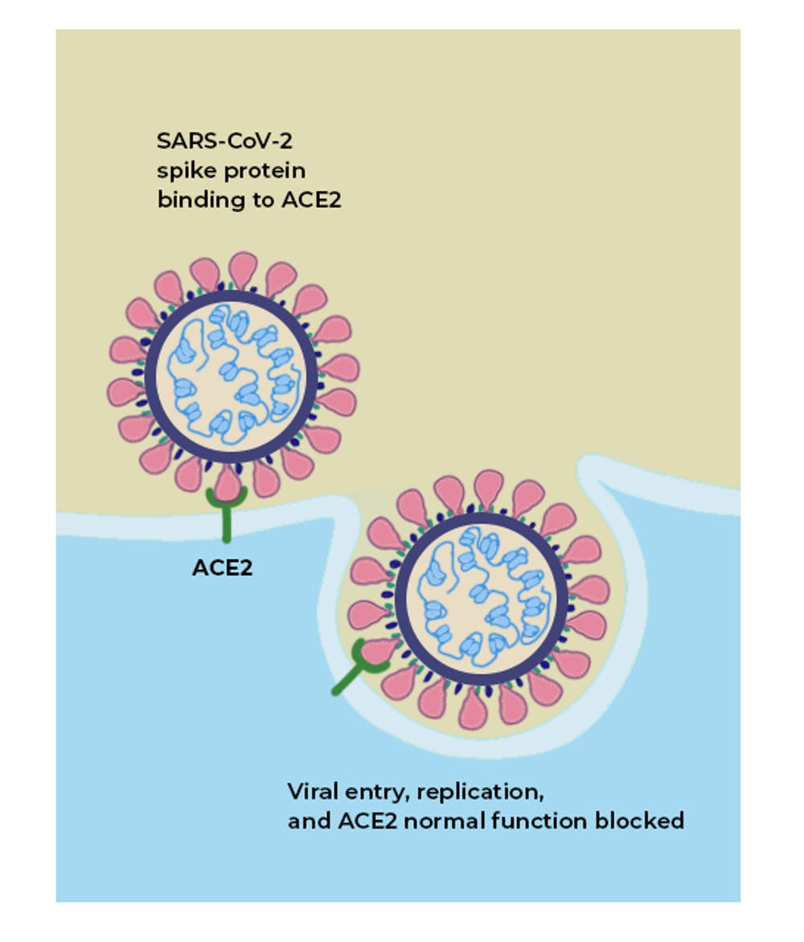

ACE2 acts as the receptor for the SARS-CoV-2 virus and allows it to infect the cell.
ACE2 is a protein on the surface of many cell types. It is an enzyme that generates small proteins – by cutting up the larger protein angiotensinogen – that then go on to regulate functions in the cell.
Using the spike-like protein on its surface, the SARS-CoV-2 virus binds to ACE2 – like a key being inserted into a lock – prior to entry and infection of cells. Hence, ACE2 acts as a cellular doorway – a receptor – for the virus that causes COVID-19.

Where in the body is it found?
ACE2 is present in many cell types and tissues including the lungs, heart, blood vessels, kidneys, liver and gastrointestinal tract. It is present in epithelial cells, which line certain tissues and create protective barriers.
The exchange of oxygen and carbon dioxide between the lungs and blood vessels occurs across this epithelial lining in the lung. ACE2 is present in epithelium in the nose, mouth and lungs. In the lungs, ACE2 is highly abundant on type 2 pneumocytes, an important cell type present in chambers within the lung called alveoli, where oxygen is absorbed and waste carbon dioxide is released.

What is the normal role ACE2 plays in the body?
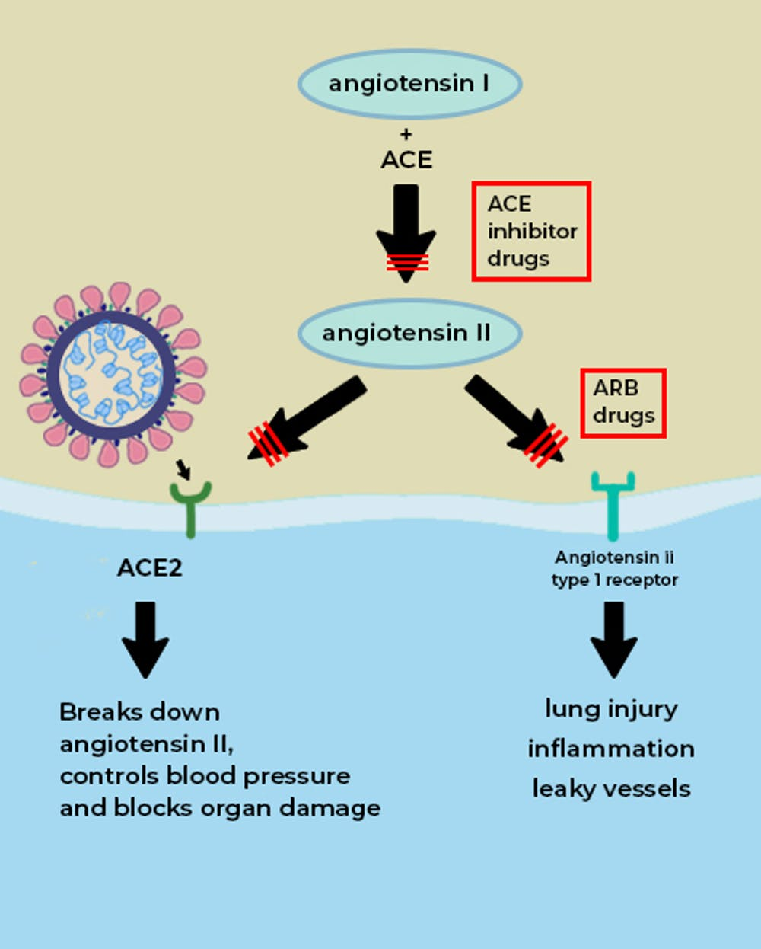

The ACE enzyme converts angiotensin I into angiotensin II. The main role of ACE2 is to break down angiotensin II into molecules that counteract angiotensin II’s harmful effects; but if the virus occupies the ACE2 ‘receptor’ on the surface of cells, then its role is blunted (red lines). Drugs called ACE inhibitors inhibit the formation of angiotensin II, which would otherwise interact with the angiotensin type 1 receptor to produce tissue damage and inflammation. Drugs called ARBs block angiotensin II from interacting with its receptor.
ACE2 is a vital element in a biochemical pathway that is critical to regulating processes such as blood pressure, wound healing and inflammation, called the renin-angiotensin-aldosterone system (RAAS) pathway.
ACE2 helps modulate the many activities of a protein called angiotensin II (ANG II) that increases blood pressure and inflammation, increasing damage to blood vessel linings and various types of tissue injury. ACE2 converts ANG II to other molecules that counteract the effects of ANG II.
Of greatest relevance to COVID-19, ANG II can increase inflammation and the death of cells in the alveoli which are critical for bringing oxygen into the body; these harmful effects of ANG II are reduced by ACE2.
When the SARS-CoV-2 virus binds to ACE2, it prevents ACE2 from performing its normal function to regulate ANG II signaling. Thus, ACE2 action is “inhibited,” removing the brakes from ANG II signaling and making more ANG II available to injure tissues. This “decreased braking” likely contributes to injury, especially to the lungs and heart, in COVID-19 patients.
https://www.asbmb.org/asbmb-today/science/051620/what-is-the-ace2-receptor

